AIM : Write a program in c to perform linear seach of an array

Input : 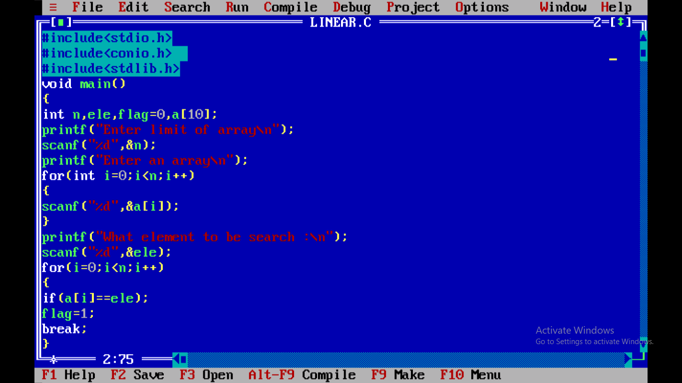

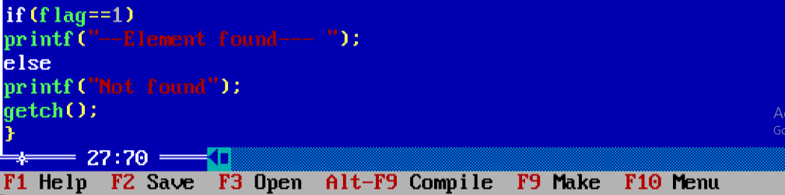

Output : 